# Visualization and editing of network connections

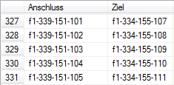The project was run from February 19 until April 4. My task was to create a website which would display connections between certain school devices. For example a connection between a switch and a router. Usually you would search for specific rows in a database table to find the connection. It takes too much time. My job was to simplify this operation and find a solution to this problem. I decided to create a website because it is easily accessible on both desktop and mobile devices. To create a website I first needed knowledge of HTML and PHP. HTML is a markup language for creating webpages. Webpages can include writing, links, pictures, and even sound and video. HTML is used to mark and describe each of these kinds of content so the web browser can show them correctly. PHP is a scripting language that helps people make web pages more interactive by allowing them to do more things. In the first two weeks of my project time I learned basics of these two languages, then I created a simple website that would fetch data (connections) from a database and display it like this:

s1-355-121-019 --- s1-355-121-019 --- j1-355-161-119 --- o1-355-191-001

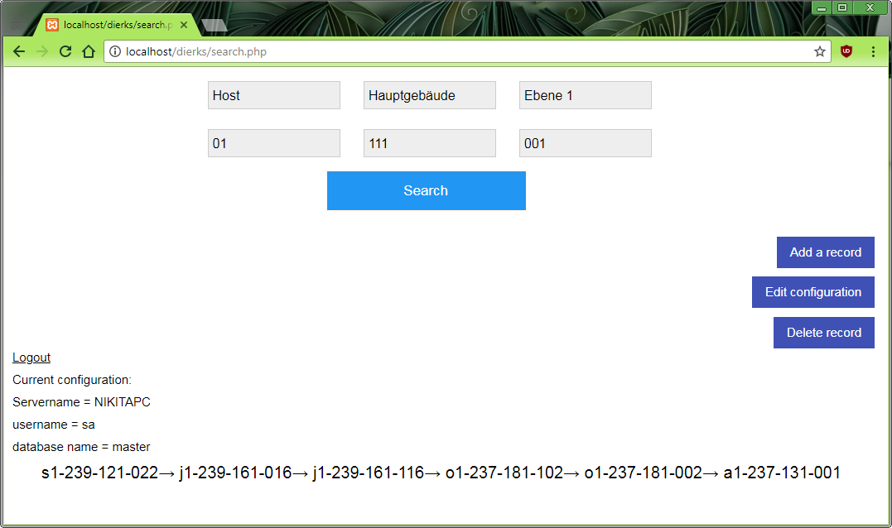After that I added CSS so that the website will look more appealing and began adding additional functions: adding a record to the database, deleting a record from the database and configuring database access parameters. In the end the website looks like this:

Because my project is very specific it does not have a commercial use.